**Memories of working at St. Andrew's Hospital (1984-1990)**

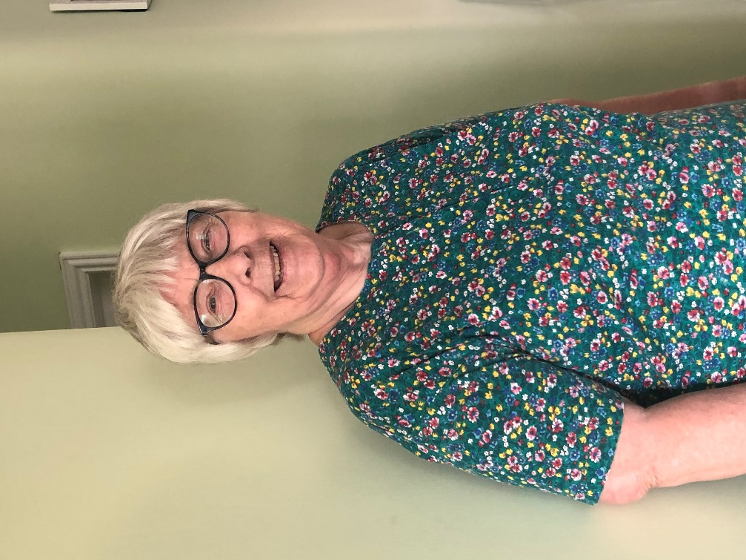

**Rita Powell talking to Amanda Grimley for WISEArchive on 21st July 2022   
in Norwich**

We came to Norfolk from Yorkshire in 1978 because my husband had a promotional job at the Norfolk and Norwich Hospital. I didn't start work until my children were old enough to do without me at lunchtime! I started at the day hospital in Thorpe St. Andrew where we had day patients, obviously. Sometimes they had to come once; sometimes they had to come anything up to five times. This was either pre going into the hospital or when they'd been in hospital and they'd gone home, we still kept an eye on them. I was a receptionist in the day hospital but I also went round every Monday afternoon to do the filing on every ward in the hospital.

**St Andrews Hospital in the 1980s**

St. Andrew's was a large Victorian asylum. It had a grand entrance with a big roundaboutwhich had grass and flowers. The main entrance was straight ahead but you had to go round the roundabout. It had wings towards the East and towards the West. On the East side, at the back of the hospital, was the Day Hospital which was a new building attached to the hospital. On the West side of the main entrance were in-patients. As you came out through this main entrance, straight across the road was a long drive which took you up to the North side of the hospital. This was also a very old building and they were again long term patients. They also had one ward which was full of Polish people who had helped us in the war. Then after the war they couldn't find anywhere to live and they were put temporarily into this hospital ward but they never actually left, which is quite sad.

I worked at the day hospital from 1984 to 1990. I worked three days and two half days. My boss was based in Hellesdon so that was very good and I was more or less left to my own devices. The River Yare wasn't too far away and occasionally we used to take sandwiches and have a walk down to the river when the weather was nice of course. One of the things I really enjoyed seeing was Bernard Matthews, the man who said, `Bootiful.' He had a wonderful yacht which was massive. It even had a ballroom. It was down on the river there because it was all being done up and what have you for him to go off in again the next time he wanted. Other times I went to the canteen and the food there was absolutely fabulous. In fact, I think some of the doctors came from the Norfolk & Norwich Hospital just to eat at St. Andrews because it was so good! I had eaten at the Norfolk & Norwich Hospital and I didn't like the food there but St. Andrews was really lovely.

I didn't wear a uniform and that brought up something interesting. When we had a new psychiatrist start he noticed that the patients came into my office to have a chat with me more than they actually talked to the nurses so this led to the nurses in the day hospital not wearing uniform and it actually worked much better.

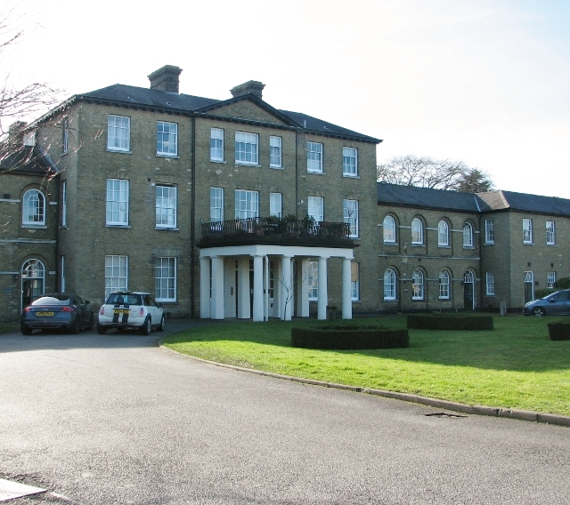

**The day hospital**

A typical day - I used to go early and get there for maybe half past eight and then leave early at half past four because that fitted in and it was OK with everybody else. My main job, I suppose, was when the patients came I helped them take off their coat and hung it up for them and got them a cup of tea or coffee. Unfortunately, I have a lot of static and this was in the days when people wore Crimplene or nylon coats and things and it was a nylon type floor and I used to give the patients shocks! Some of them understood what had happened I did apologise but some of them just didn't know and they were looking at themselves and looking at me very worried and I felt awful about it. On a Monday afternoon, as I've said, I used to go up to the North side and South Side into every ward just to do the filing. Lots of the patients were just sitting quietly but a lot of them you had to have a word with if they'd ask you questions. You could have an actual conversation with them.

Anything up to about 18 people would come into the day service on the day. Some of them came every day; some of them perhaps came once a week. Patients came from all over Norwich and they were brought by ambulances, not the ones that we used for patients who were ill, but like a mini bus. Some of them, their relatives brought them in a car but most of them came by ambulance and the ambulance crew always made them laugh. They'd come in and have a cup of coffee or a cup of tea as well.

I used to walk to work. I only lived a mile away from the hospital and it was lovely. Walking round the back of the hospital was quite interesting because I went down Griffin Lane and as the day hospital was at the back of the hospital I walked along there. There was a very high wall between the road I walked along and the hospital. In the spring and summer walking along there and back again the irises were out because there was marshland and it was absolutely beautiful but walking home at night was a different story. I wasn't frightened but there were lots of bats that used to come flying over the wall and swoop down and they never caught you because they'd got this wonderful sound system. They don't actually get into your hair or whatever people say. So for me it was fine but one of the members of staff who lived quite close to where I lived found out and she insisted that I went home with her and her husband. But come spring, I used to start walking again because I really enjoyed it.

Inside the hospital there were double locks. You had to pull the handle at the top and the handle at the bottom at the same time. The patients didn't realise this is what they had to do, so it was quite safe for them to wander. We knew, so everything worked fine.

My typewriter was an ancient heavy duty typewriter. The proper use for it was to type out metal tags. I occasionally got an order from Hellesdon Hospital - would I type out so many of these tags. So, I suppose as well as seeing the patients in and helping them off with their coats and getting them cups of tea the other job of mine was to order transport for the patients with the ambulance people.

Most of the patients who came into the day hospital had dementia or depression. Some of the patients attending had electric shock treatment. A lot of people will frown at this but most of the patients didn't mind it. I think they were put to sleep before it happened. There was one lady who was telling a new lady that had come in, `You want to ask them for the electric shock treatment. I love it because it makes my hair curl.' That is a true story!

We also had a dentist in the day hospital who came every so often. So patients would come and sit in the waiting room and go through to the dental office. One story was of mad panic. The dentist had had all the patients from a particular ward and examined their teeth. When he came the next time one of the ladies there had had great fun. At night she'd gone round taking everybody's teeth - that were in pots of course - and she mixed them all up. It took the dentist weeks to find out which set were for which person. In fact, he actually considered getting new dentures for all the patients [laughs].

**The secure unit**

By this time, on the North side of the hospital, there was a secure unit for people who were violent. They did come down to our day hospital every so often for dental treatment or electric shock treatment. There was one man who was extremely strong, not surprising because the main thing over in the secure unit was a gym. So most of the people over there spent time in the gym. His party trick, when he got angry, was to go into the toilet area and break off the taps which he could do quite easily. So, the plumber had to go there quite often [laughs]. A lot of people and the staff were worried about him but I always had my door open to the waiting area and there were always two men with him. He came into my office and I just said, `What can I do for you?' and he said `Have you got a cigarette? Can I have a cigarette?' and I said, `I'm afraid you can't because you're going in for your treatment. But when you've had your treatment you come back into the waiting area and I will go and make you tea or coffee and I'll find you a cigarette.' So he just said, `Right, thank you.' and went and sat down. He was very, very good. I saw him quite a lot because he used to come down for dental treatment as well.

**Characters**

We had quite a lot of characters. We had a lady who was in the main hospital. She was a ballerina and she had dementia. She was very, very good at escaping the hospital. On two occasions she was actually found dancing in a pond with a water feature in somebody's garden on the Yarmouth Road and brought back to the hospital. I felt very, very guilty because on the way home one day I saw this lady walking from the hospital towards River Green and I said, `As soon as I go in I must ring the hospital.' Unfortunately, we took another lady home that night and I completely forgot about it until after dinner. I rang the hospital and said about this lady and the receptionist there said, `Oh, she's just come through the doors Rita - she's wet through.' I went to apologise to the charge nurse the following morning and he was quite happy about it. He said, `Don't worry. If you'd have phoned we wouldn't have got rid of the fur coat.' So I said, `Sorry?' He said, `You know that awful moth eaten coat that she won't get rid of? Well, she jumped in the River Yare at River Green with the fur coat.' Unfortunately, the fur coat finished up at the bottom of the River Yare so they were quite pleased about that. The same lady also had male admirers. She used to walk round the grounds with her arms, not folded, but held across in front of her and she always had artificial flowers, sometimes real flowers, that she picked in the grounds. If none of these were available then she had soft toys. She carried them around with her. But very often she had a gentleman on one arm and sometimes a gentleman on the other arm as well so she was quite well known to us all.

There was young man who was on the North side of the hospital and he was allowed to walk round the grounds. Having met me once on the ward when I was doing the filing he had a chat and said where did I work and I told him where I was. So, after that it became a thing that he used to come past where I worked which was up a ramp. He'd stand at the bottom of the ramp and wave to me and he'd stand there until I actually saw him. I didn't always see him straight away. He was a lovely young man. A few years later they moved some of the patients from the North side over to Hellesdon Hospital and I went to Hellesdon Hospital for three days training to be a first aider in the department. He was there and he came running across, flung his arms round me and sat while I had my lunch outside. This happened every day of the three days. He'd come and find me and we'd have some sandwich lunch together.

We had another lady who'd had a baby when she was unmarried and very, very young and they'd taken her baby away from her. So, wherever she went she took a baby basket with a baby doll inside. She really thought that was her baby. Fortunately, they managed to trace her son and he was interested in meeting her. They did get together, even if it was only once or twice a year, but she still had her baby doll. One of our nurses, when she left and had a baby, she came back in with the baby for us and the patients to see. She brought all the baby's clothes, the first stage clothes, for this lady's baby doll.

**Parties and pantomimes**

Around Christmas time we always had Christmas dinner and a Christmas party. There was another day hospital at West Norwich Hospital and on the day of our party the receptionist there would liaise with the consultant about who actually had to go in on that day. The rest of the patients would be put in on another day and I did the same thing for them so that actually on the party day we could get just about all of our patients in for the Christmas dinner and the party.

The Christmas parties in the day hospital were lovely. We had the children from the local primary school come down. They used to come in with the music teacher and they sang carols. Some of these we all joined in with. The staff used to dress up and the patients loved it. I had a total disaster one year. I dressed up as Jack Frost and I made a top out of a black bin bag and I made a skirt out of a black bin bag and I sprayed them with silver paint. I also got a silver spray for my hair and I made a sharp, sparkly little crown and that was Jack Frost. By the time the day was over my face, hands, arms and legs were silver - the whole of me was silver. When I got home - I had to walk home like that - my children and my husband howled with laughter. So I decided I'd go and have a bath straight away. Well, I got into the bath, washed the stuff off and it all sat on top of the water so that every time I stood up it just coated me again in silver. I just couldn't get rid of it. So, in the end my husband came up and I had to start at the top and work my way down and he just kept filling jugs and pouring them over me. Then it was another job - I had to clean out the bath because this silver just got everywhere [laughs]. This went on for years with the parties and things like that. We all really enjoyed it but then staff changed and we didn't have the parties we had just a little sing song with one of the staff playing a guitar every day. A lot of them really missed the parties because they thought of us as their family. They didn't have any family and they tried to bring us presents which we weren't allowed to have. At one point a lady had been to the Norfolk & Norwich Hospital. It was trip from one hospital to the other because they'd got a sale on. She bought things like drinking glasses and water jugs. She'd got something for every member of staff in the day hospital and we were told to give them back. I said, `What are you going to do with them?' `We'll sell them when it's our sale,' and I said, `You can't do that because the patients will see them.' Actually it was very naughty of me but I stuck it out and wouldn't give back my lovely drinking glasses - three drinking glasses with birds painted on them - because she thought I loved the birds which was actually true. It was so sad because she thought we were her family. She didn't know about us giving them back but it was so thoughtful of her.

One of the things that I remember fondly was the pantomimes. The staff used to put on a pantomime for the patients and their families and friends and our families and friends. One day, we took a group of friends to the pantomime and they were all fit, young men and as we approached the hospital one of them said, `Are the patients going to be there as well?' and I said, `Oh yes.' and he was terrified. We all laughed at him but he said `Well, what happens if somebody gets violent?' and I said, `Nobody's going to get violent.' I said, `I work here with these patients every day. Do you think I'd still be working here if they were going to get violent?' Anyway, they enjoyed the pantomime. They were always local and always a good laugh.

**Remnants of the old hospital and moves to Hellesdon**

The hospital had at least 15 wards and each ward would have a charge nurse or a sister, a staff nurse and other nurses. I suppose from ward to ward it depended how many nurses they actually needed. The nurses were all mental trained. It wasn't just someone who was working in the hospital. They had to have mental training background. Then there were assistant nurses who helped lead groups of the patients. We did craft things with them. One year they knitted a scarecrow. Then he got a girlfriend and then there were his parents and grandparents and then the children. All these things were knitted even down to tiny little ladybirds and leaves covering up the baby twins in a pram. Everything was knitted. They got them knitting and they managed to make two lots. One lot was sold and the other lot was auctioned off. The patients loved it because some of them could knit little things, some of them could knit big things. They also played games. Later on, they actually did less and less of the knitting and things like that and more and more of what they called `mind games' and I don't think the patients - that's just my opinion - I don't think they enjoyed it as much. Another thing that we all did - I managed to get hold of a lot of lavender and we made some lavender bags. We got the patients stripping the lavender. Some of the patients had arthritis and I took some combs, clean combs, and they could strip the lavender off with the combs. So, they were very happy because it was a lovely smell and they couldn't do it with their own hands because it was too painful.

Another thing that, to me it was funny, was the cellar. There was a lady who was a secretary and she did births, marriages and deaths. Now, because it's an old people's hospital there were no longer any births. I don't think there were any marriages either [laughs] but when it was first opened there were lots of young people who were pregnant and unmarried and they were put into the mental hospital by their parents. Unfortunately some of them were never taken out again.

The lady who was doing all this recording of births, marriages and deaths amongst other jobs, she had to file all the important hospital documents. A lot of them were filed in the cellar which I admit was rather spooky. My friend didn't like to go down there so if I got a phone call and she said, `Hello, it's me.' I knew I was expected to go up to her office and we'd go down the cellar together. One day, she had to go into the cellar on her own because I wasn't there. I was on holiday. She fell and broke her ankle. So although it was a wide staircase it was marble stairs and she slipped on them and broke her ankle. There were big bookcases and filing boxes and things. We had a look round and there was a grate in the ceiling which was open to the sky. This was right at the front of the main entrance to the hospital and in the very olden days it's where the families of the people who were incarcerated there used to come to see their relatives. We pulled away one of the filing cabinets and behind there were shackles. They were on both sides, not directly under this grate but on both sides of the grate which was very upsetting but that's how it was when it was called a Victorian lunatic asylum. Things were much better. I can honestly say I didn't have any doubts about the staff or the patients. They were well looked after, happy and cared for.

There was one lovely lady who lived there from being a young teenager. When they moved everybody over to Hellesdon Hospital she didn't want to go. But, she had to go. She kept coming back and she almost got run down on the Yarmouth Road. In the end they made a flat for her. It was right next door to the psychiatrist's office and she always used to say that she lived next to this doctor but of course if she had got lost nobody would know who this doctor was or where she was! She was a lovely lady and it was just her home. She didn't want to be anywhere else.

One of the sad things was upstairs on the wards near the day hospital. There were patients who came in for assessment. They either came to the day hospital after so that we could keep an eye on them and see how they were coping or they came to the day hospital first. If they were needing to be in hospital they were then taken upstairs. We had two patients who were only in their forties because they had pre-senile dementia. They were both beautiful and lovely natured, really nice people but it was so sad to see them mixing with the older people and they should have been enjoying time at home with their husbands and their families. One of them spent hours talking to herself in the mirror. It was a full length mirror on one of the corridors. She'd stand there for hours talking to herself. They always made me want to cry so I had to take myself in hand before I went onto the ward.

At the hospital they had a lot of land and allotments. They kept pigs and grew vegetables. They had the most wonderful cricket pitch. This was all on the North side of the hospital. Gradually, one thing after another stopped. When I started they still grew daffodils and sold daffodil bulbs. The patients on the North side were moved to Hellesdon Hospital because the NHS wanted their offices to be on the North side and it was actually not very nice there, everything was dark brown. So, they moved them to Hellesdon which was more modern, more pleasant and the old part up the North side was the finance department for the NHS. I left in 1990 but when it closed in 1998 the patients from the other hospital had all either died or been moved to Hellesdon. Most of them were quite old by this time so there were very few left. I'm not sure but I think there is one ward at the West Norwich Hospital and there is certainly a day hospital there. It's all called the Julian Centre. Another thing is the chapel. The chapel was on the opposite side of the corridor from the day hospital. It was a beautiful old chapel, very large so they were all expected to go to church every Sunday morning. Underneath there was the mortuary which was still used but not very often. There was one lady there who had, like I said before, went in there because she had a baby before she was married and no-one took her home again. She was in her 80's when I knew her and she still cleaned the chapel because that was her job. That was what she'd done all her life staying in the hospital. The cricket pitch is still there but it's now more or less a wild flower meadow. I have been up there because we take our son's dog and he loves to run around. I don't know whether I preferred the cricket pitch or the wild flower meadow.

I did enjoy my time there. I really enjoyed it but things weren't quite what they used to be. So, I moved to the Norfolk & Norwich and that was the end of my time at the day hospital.

