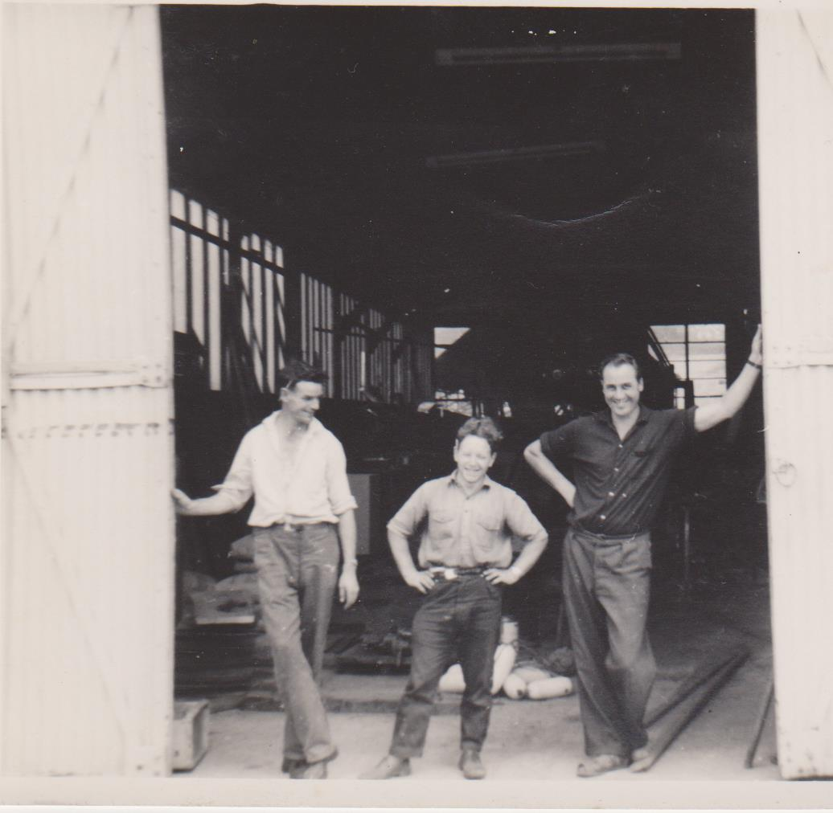

Jack & Peter the two guys who taught me my trade

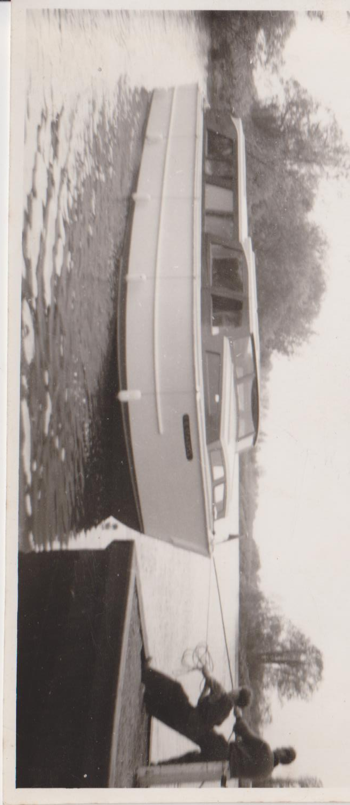

The last wooden hire boat we built that went to the Boat Show

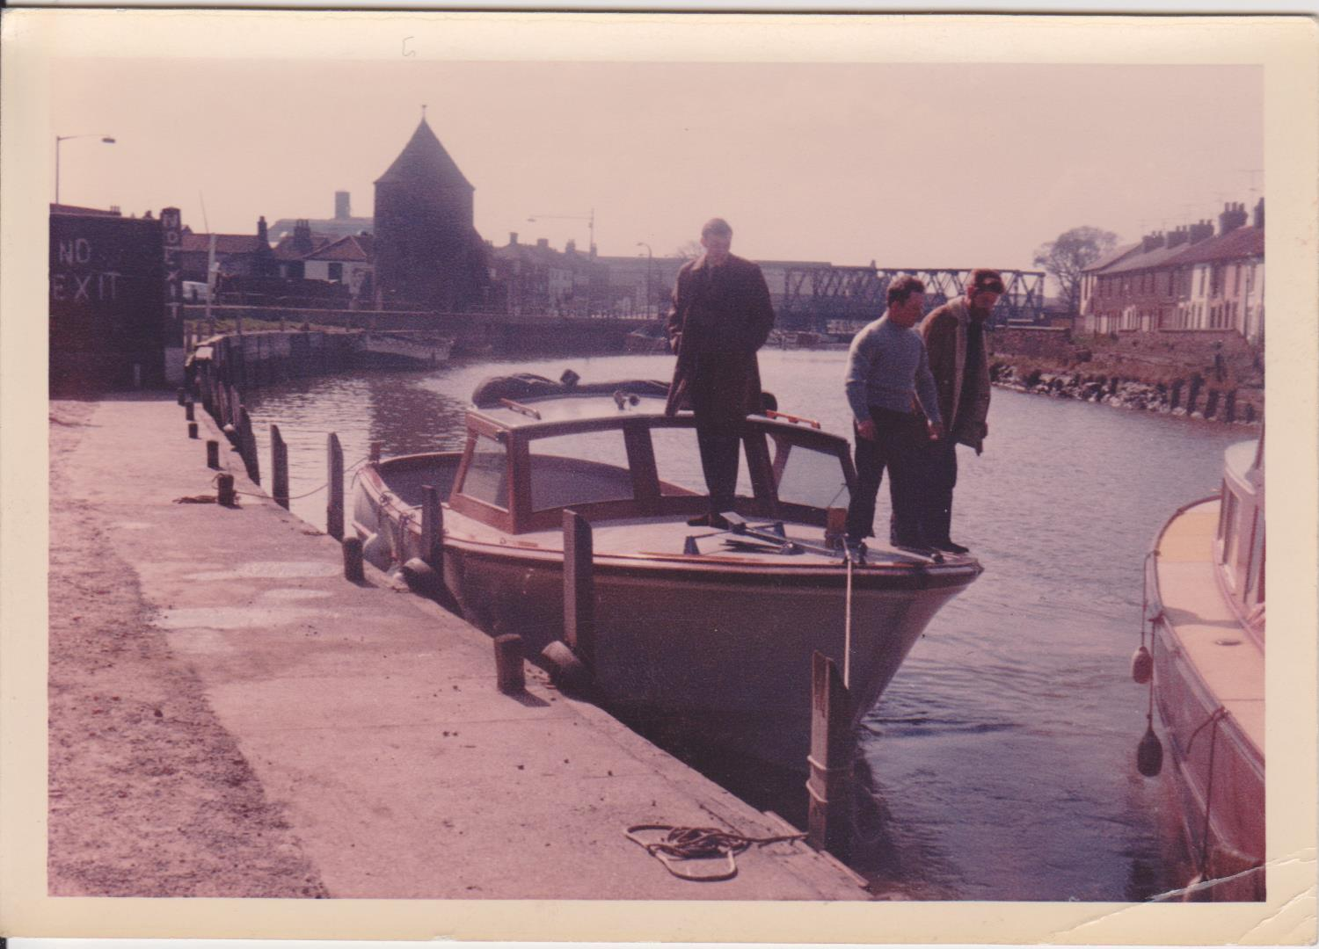

The first Shark 8 we built at the Bure quay about to go to sea on a demo

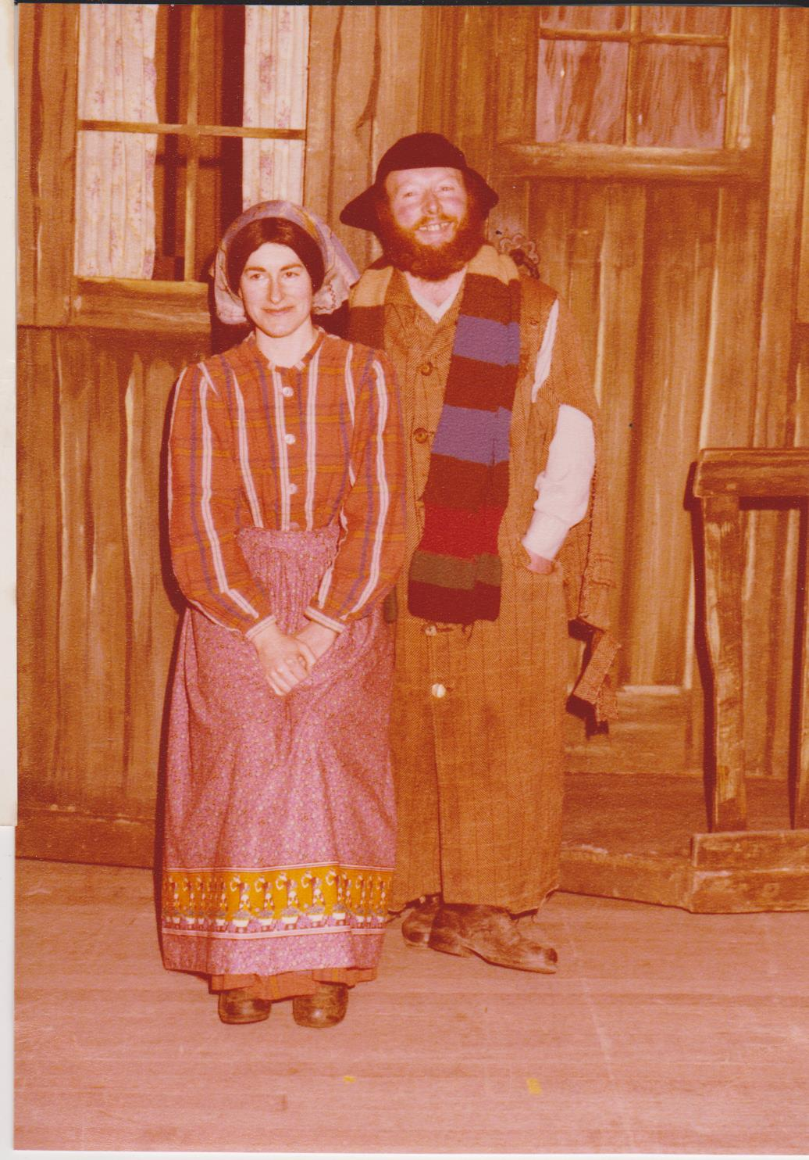

Barbara & I in our Fiddler on the Roof costumes

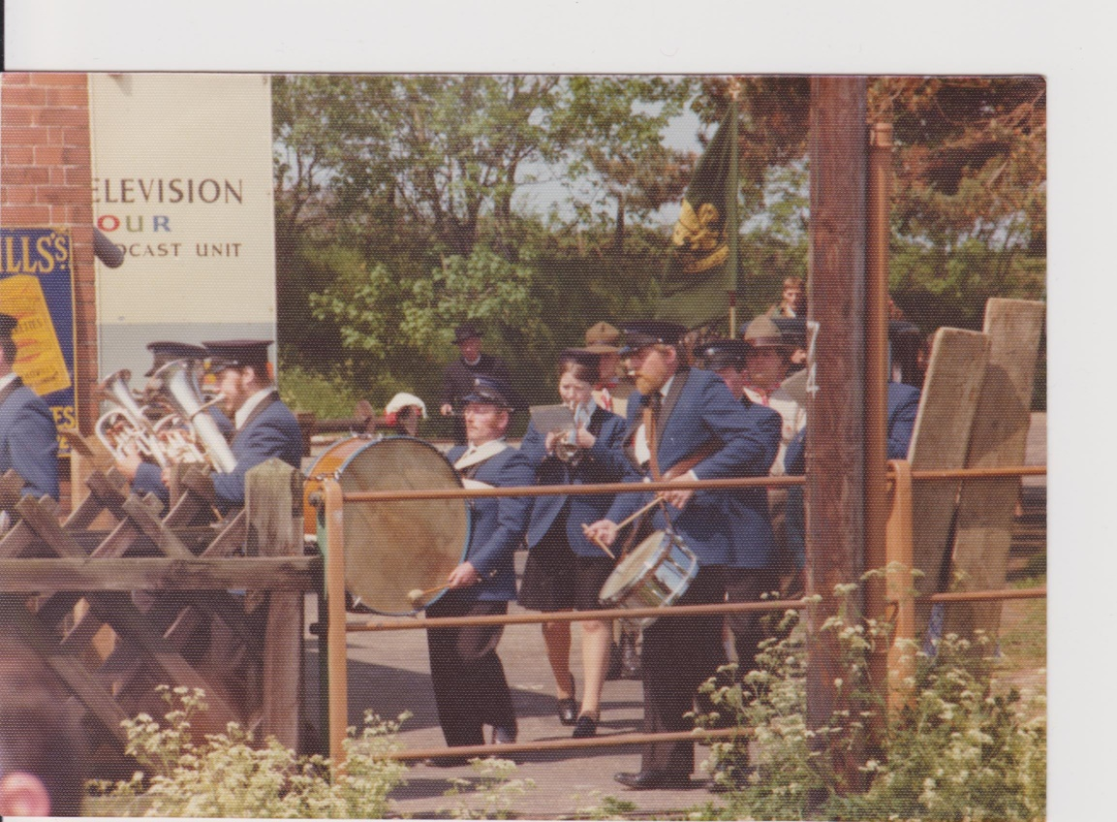

The Norwich Lads Club Band leading the villagers onto the platform during the filming of “Backs to the Land” an Anglia TV production

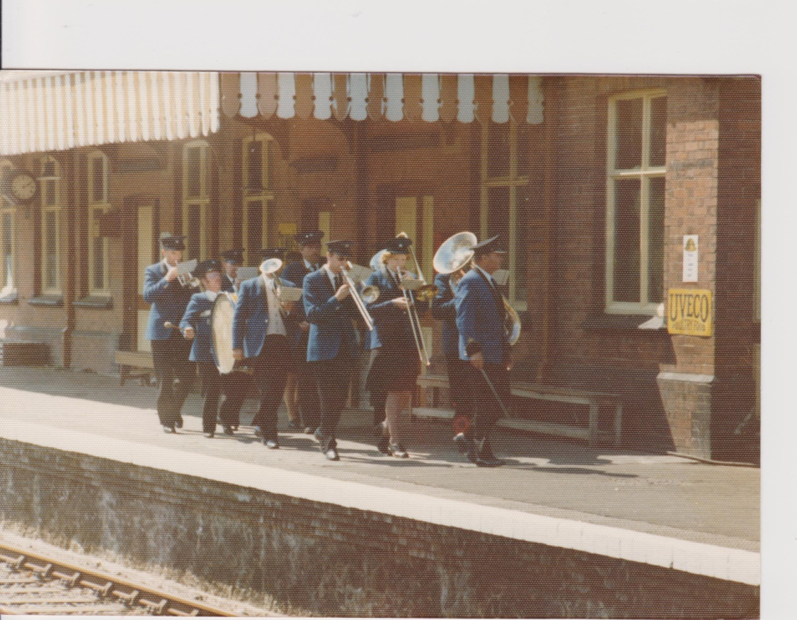

Marching off